
Multi Factor Authentication
Set-Up Instructions
14 January 2022
BlueScope Australia
Contents
OVERVIEW 2
INTRODUCTION TO SETTING UP MULTI-FACTOR AUTHENTICATION 2
PART 1: ACCEPTING AN INVITATION TO JOIN THE BLUESCOPE AZURE NETWORK 6
PART 2: SET-UP MULTI-FACTOR AUTHENTICATION 8
1. USING MICROSOFT AUTHENTICATOR APP 9
2. TEXT CODE VIA SMS 15
3. PHONE CALL BACK 18

OVERVIEW
Threats to cyber security are an ever-present danger to organisations around the world, reminding us that we must be vigilant at all times.
BlueScope is taking action to increase its cyber security, to keep your data safe and secure by changing how you login to our portals. Multi Factor Authentication (‘MFA’) will be introduced to bluescopesteelconnect.com to provide a more secure layer of security where the user accessing the system has a 2-step authenticated login.
To be able to login using the MFA 2-step authentication each user is required to have a Microsoft account.
This manual provides instructions on how to set-up a Microsoft Account and also set-up the second factor authentication option.

INTRODUCTION TO SETTING UP MULTI-FACTOR AUTHENTICATION
The process to set-up Multi-factor authentication consists of;
Part 1: Accepting an invitation to join the BlueScope Azure network
Part 2: Set-up Multi-factor authentication

To join the Azure environment, you will require a Microsoft account using the registered email address the invitation was sent to.
If you do not have a Microsoft account, you will be guided through setting one up in Step 1 (page 3)
If you already have a Microsoft account, then go directly to Step 2 (Page 5)

Step 1
a) If the email address has not been registered with Microsoft, a new Microsoft account will need to be created by going to https://login.microsoftonline.com and click the link “Create one” and follow the instructions to create one.
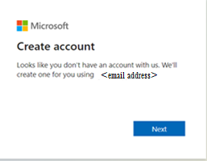
Click Next
The email the invite was sent to will appear here

b) Enter password (Use your Microsoft password not SteelConnect portal password).
Click ‘Next’
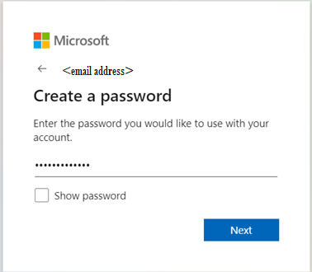
Enter your password here
Click Next

c) If your password is incorrect, reset your password.
Click “Forgot my password”
Once password is reset, Click ‘Sign In’
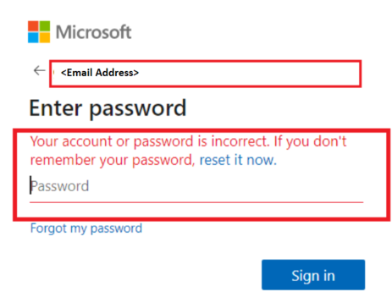
Click Forgot my password
A message notification that your password is incorrect.
Email Address in reference
Click Sign In
once password is correct

d) An email will be sent with a verification code.
Enter Code from the email
Click ‘Next’
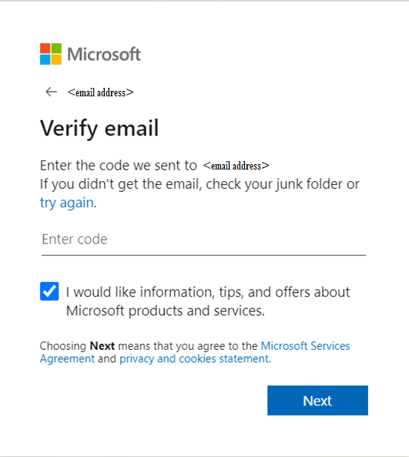
Click Next
Enter Code in email.
e) A quiz will pop up to authenticate the registration is not completed by a robot.
Click ‘Next’
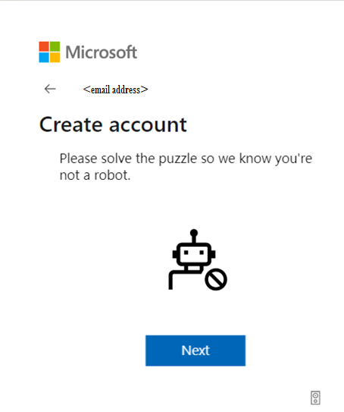
Click Next

f) A notification will appear to indicate the account to access BlueScope Steel Connect® has been created.
Another pop up box will appear to ask if you want to stay signed in.
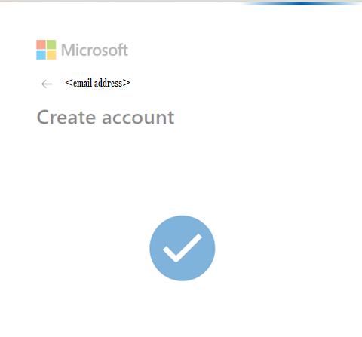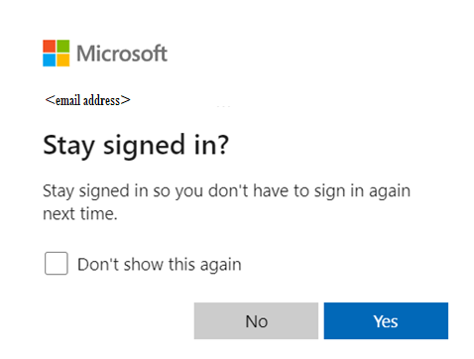
Indicated the account has been created
Click Yes if you want to stay signed in.
Go to step 2

PART 1: ACCEPTING AN INVITATION TO JOIN THE BLUESCOPE AZURE NETWORK
Step 2
- A Microsoft Invitation on behalf of Blue Scope will be sent to you to join the BlueScope Azure instance.
Click ‘Accept Invitation’

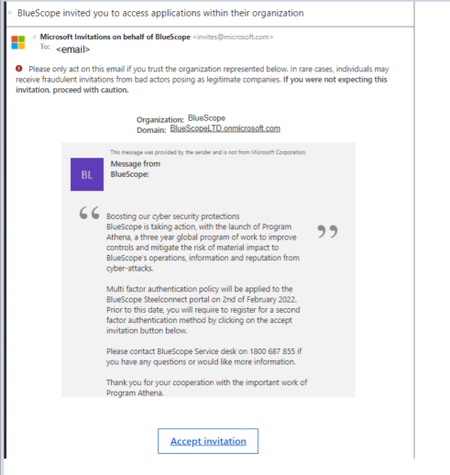

Click Accept Invitation

Enter your Password and Click Sign In
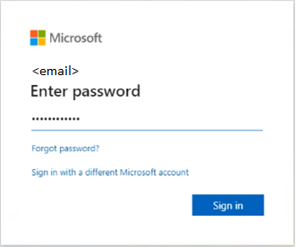

Click Sign In
Enter Password
- Click ‘Yes’ or ‘No’ if you want to stay signed in.
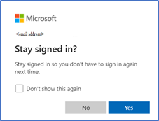

Click Yes or No

- Then Click ‘Accept’ to review permissions
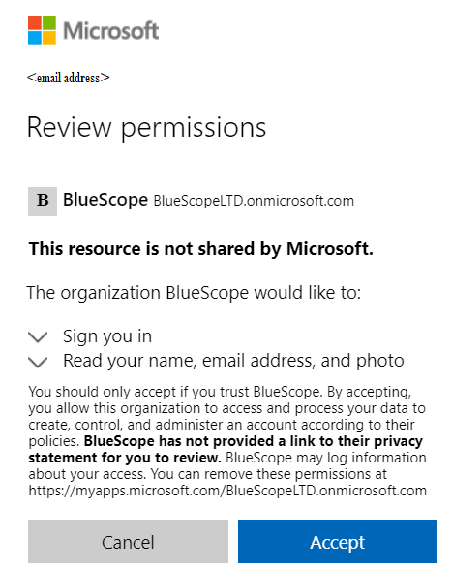
Click Accept

PART 2: SET-UP MULTI-FACTOR AUTHENTICATION

Step 3 The next steps are to register more information on the second factor authentication option.
Click ‘Next’

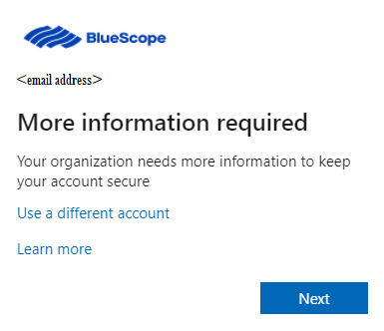
Click Next

You will require a second authenticator option to login to BlueScope Steel Connect. You can select one of three options
- Using Microsoft Authenticator App (page 9)
- Text code via SMS (page 15)
- Phone call back (page 18)

1. USING MICROSOFT AUTHENTICATOR APP

a) If you selected the Using Microsoft Authenticator App this section will outline how to set-up this option.
Click ‘Next’
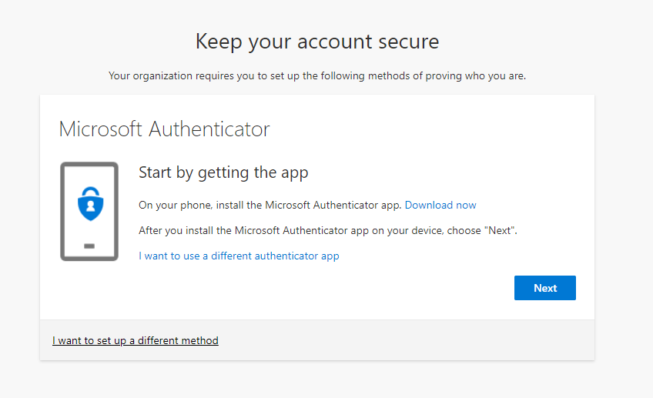
Click Next
b) Download Microsoft authenticator on your mobile phone. This is available on most mobile devices from the App store for iOS devices and Play Store for Android devices
Click ‘Get’ to install on your mobile or ‘Open’ to open the app.
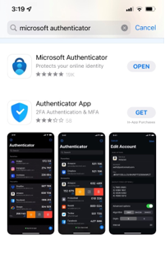
Click Get or Open
c) Open Microsoft Authenticator app to create an account
On the top right corner and
Click the (Plus icon) on iOS devices and Click on the Account with the email address you registered
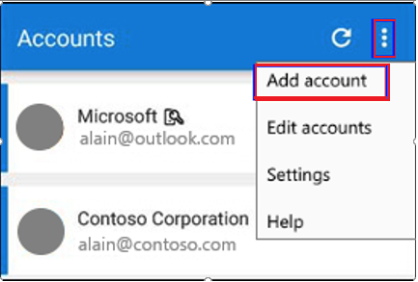
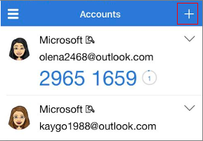
Click the (three dots) on Android devices and Click ‘Add an Account’
Click three dots
Click plus icon
Click email that you registered with to set-up the Microsoft Account
Click Add account

d) Select the account you want to create
Click ‘Work or School Account’
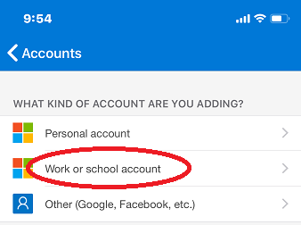
Click Work or school account
e) Go back to your computer to set-up the Microsoft Authenticator as your Multi Factor Authentication (MFA) mechanism.
Click Next
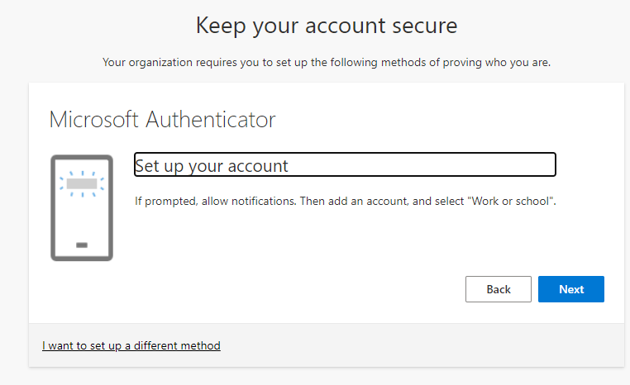
Click Next

f) You will need a QR Code to link the Microsoft Authenticator Account.
On your computer Click ‘Scan a QR Code’

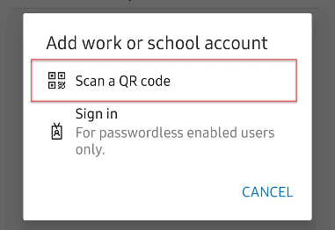
Click Scan a QR Code

g) A QR Code will appear on your computer.
Using your mobile phone, scan the QR code displayed in your computer and Click ‘Next’.
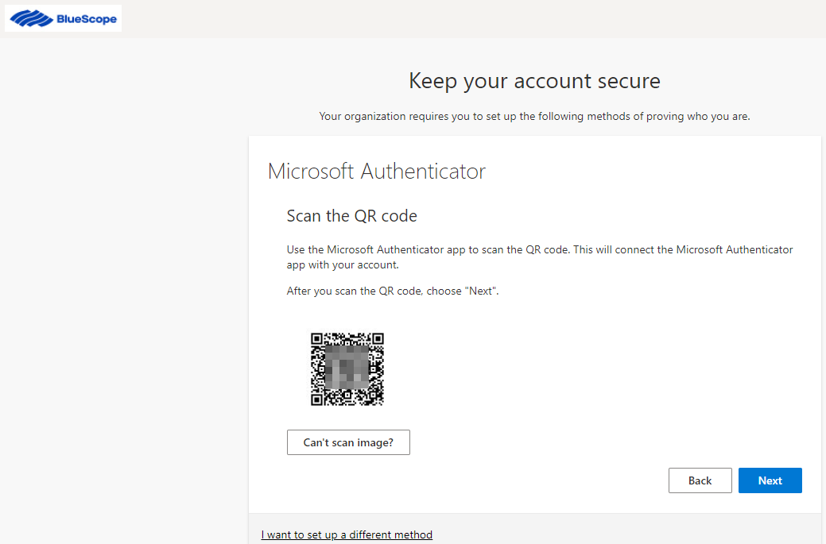
Using your mobile phone,
Scan the QR Code
Click Next
h) Wait for the notification on your authenticator app.
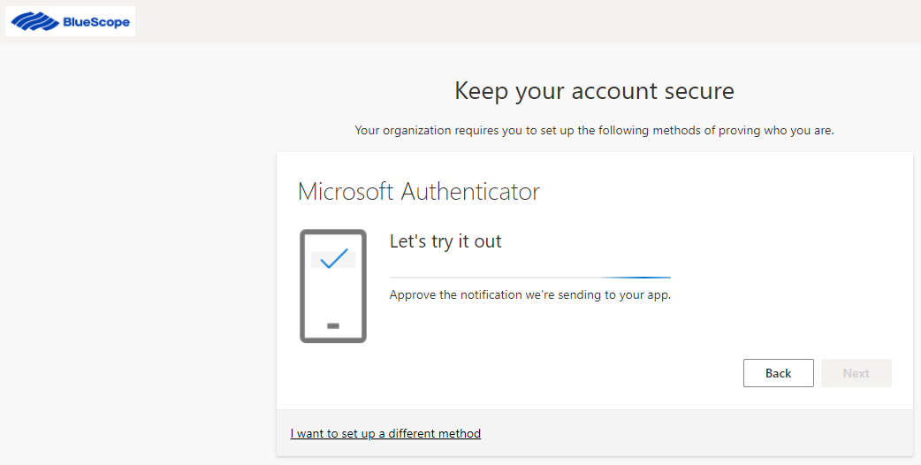

i) On your mobile approve the notification on your Microsoft Authenticator app.
j) Once the notification on the Microsoft Authenticator app has been approved a green tick with ‘Notification approved’ will be displayed on the computer
Click ‘Next’
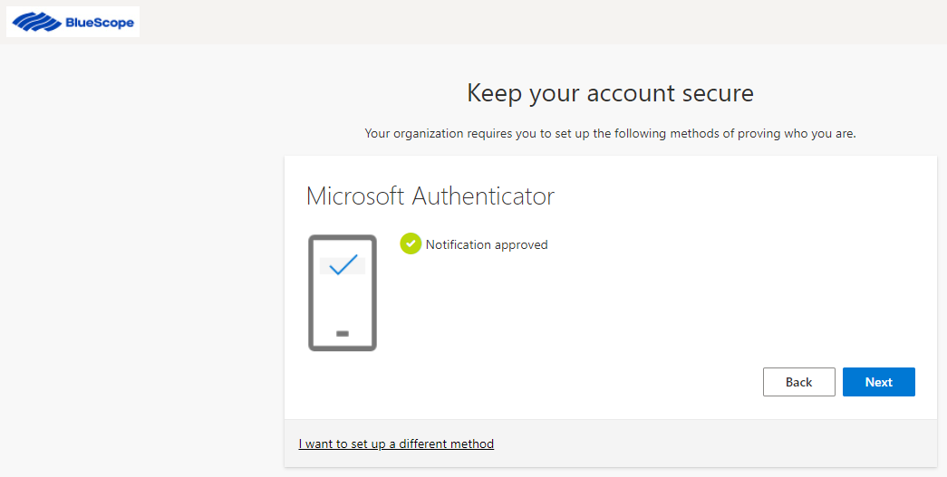
Indicates
Notification has been approved on the mobile app
Click Next
k) ‘Success’ will appear on your computer to indicate the set up for Multi factor Authentication using the authenticator app has been completed and is all ready to go.
Click ‘Done’
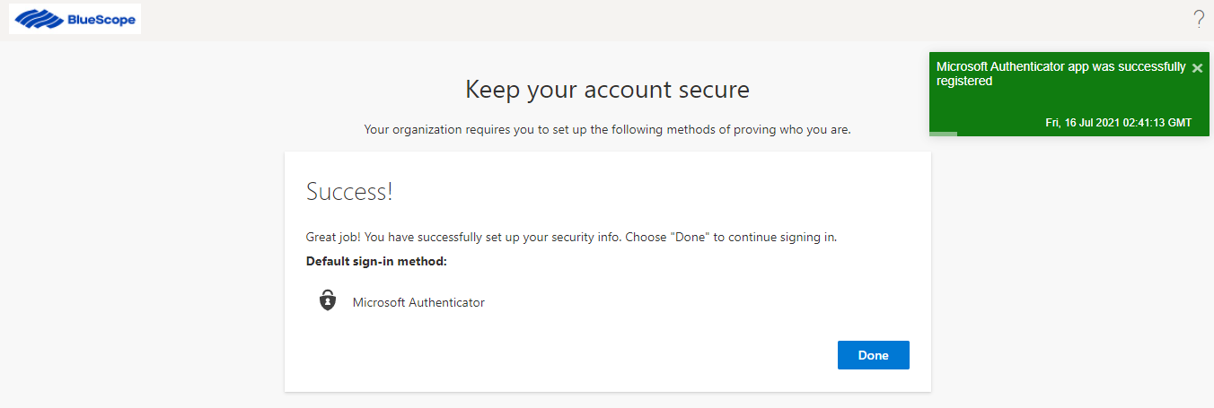
Indicates
Set-up is complete
Click Done
l) You have successfully setup MFA in preparation for when bluescopesteelconnect begins to request the extra security
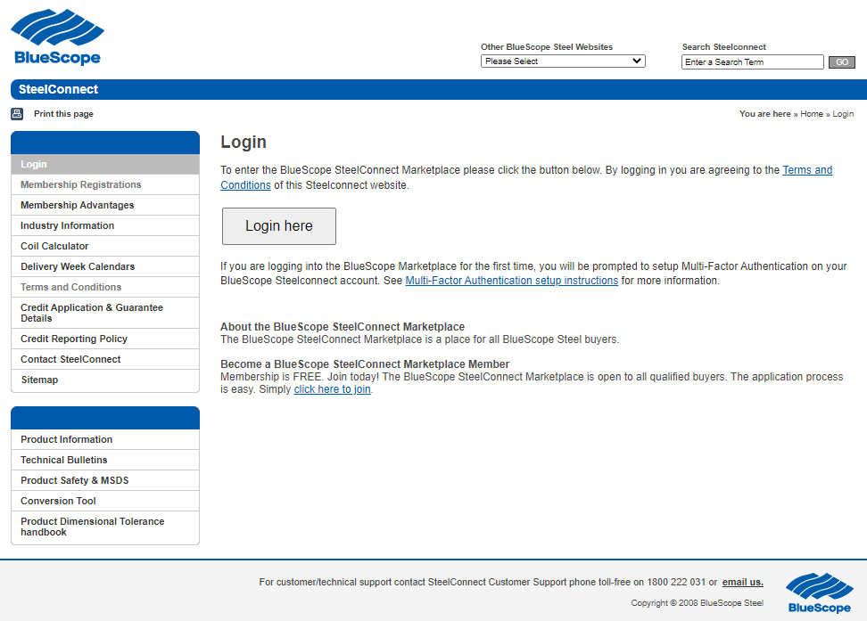

2. TEXT CODE VIA SMS
a) You will be asked to select one of the three second factor authentication options.
If you selected the Text Code via SMS, this section will outline how to set-up this option.
Click ‘I want to set up a different method’
Click I want to set up a different method

b) Select ‘Phone’ from the drop down menu.
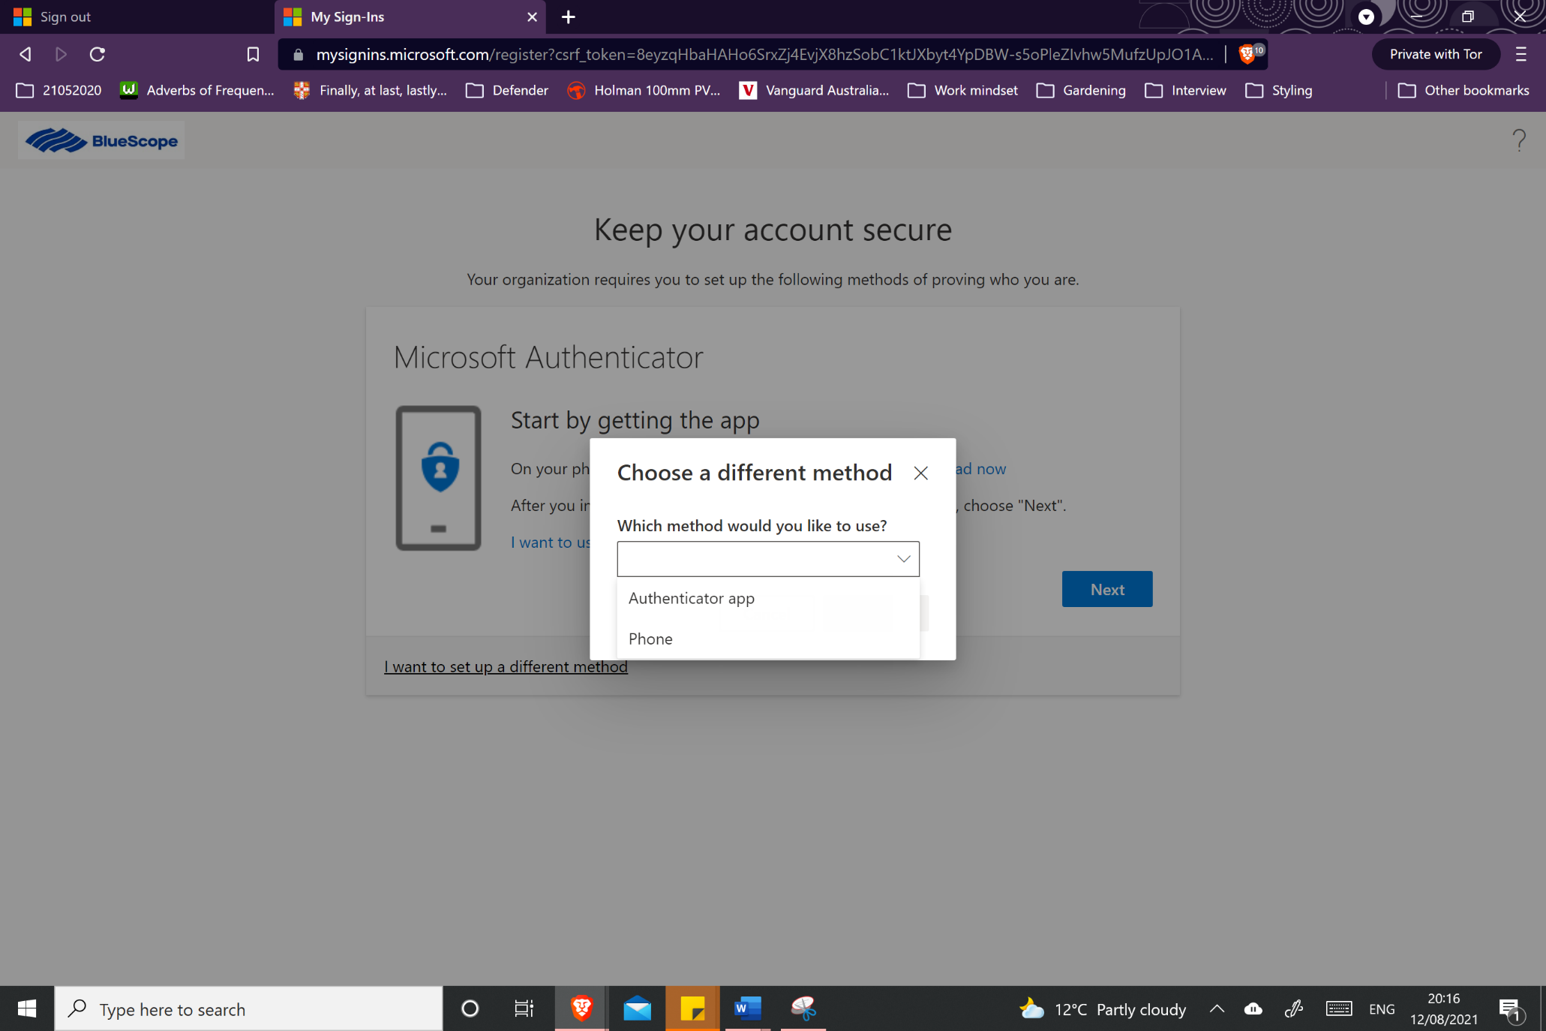
Click Phone
c) Enter the mobile number you would like the code to be sent via Text.
Click ‘Text me a code’ and Click ‘Next’
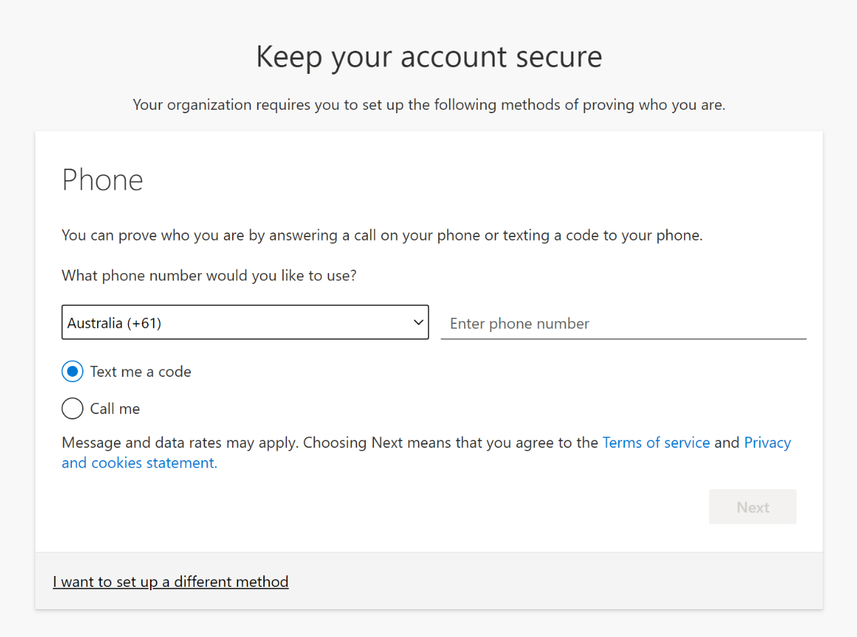
Click Text me a code
Enter Mobile Number
Click Next
d) You will receive a Code via Text to your mobile.
Enter the ‘Code’ and Click ‘Next’
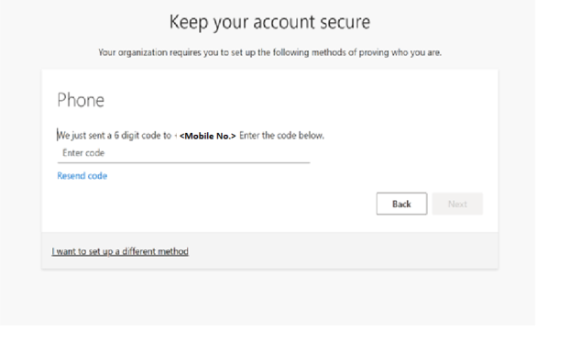
Click Next
Enter Code
e) A notification will appear on your computer to indicate the set up for Multi factor Authentication using Text Code via SMS has been completed and is all ready to go.
Click ‘Next’

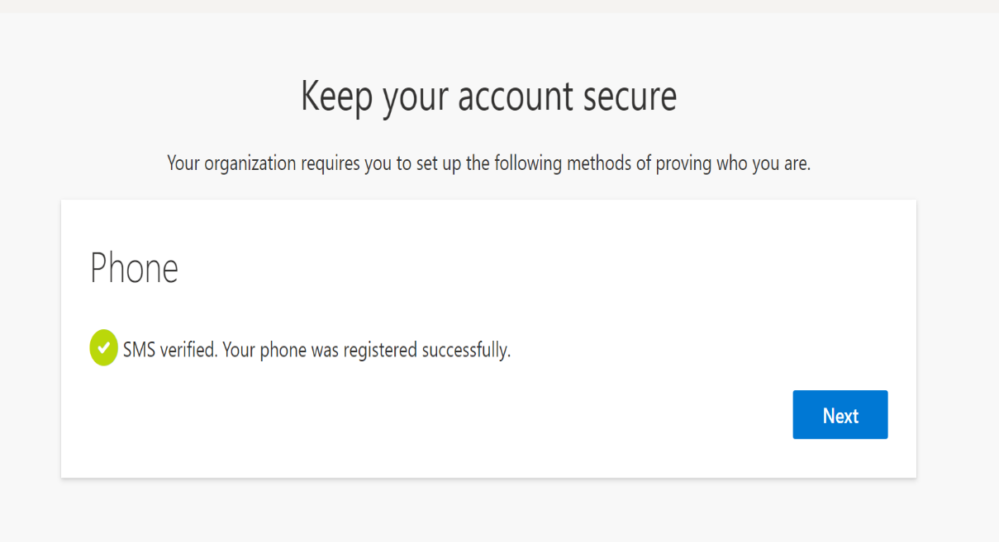
Click Next

Indicates
Set-up is complete

f) You have successfully setup MFA in preparation for when bluescopesteelconnect begins to request the extra security

3. PHONE CALL BACK
a) You will be asked to select one of the three second factor authentication options.
If you selected the Phone Call Back, this section will outline how to set-up this option.
Click ‘I want to set up a different method’
Click I want to set up a different method

b) Select ‘Phone’ from the drop down menu.
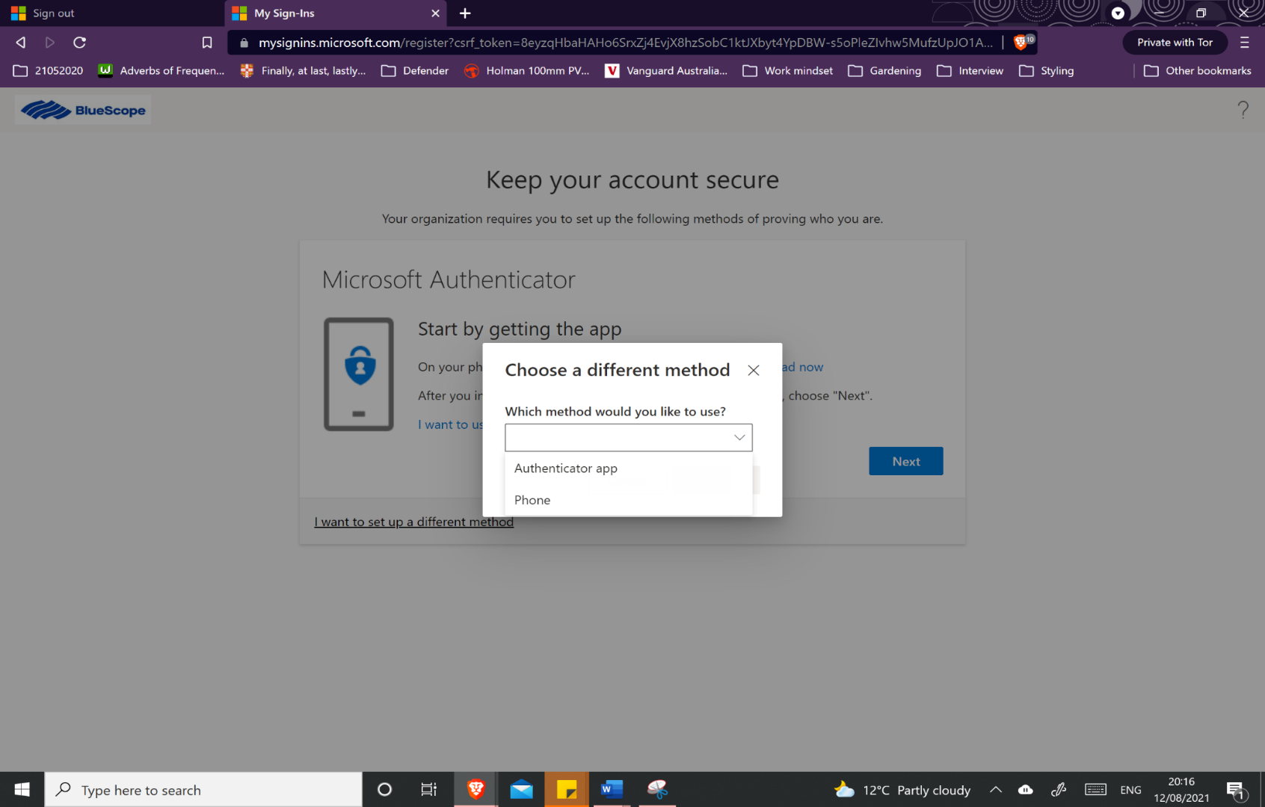
Click Phone
c) Enter the number you would like to be called on, this can be a mobile or landline.
Click ‘Call me’ and Click ‘Next’
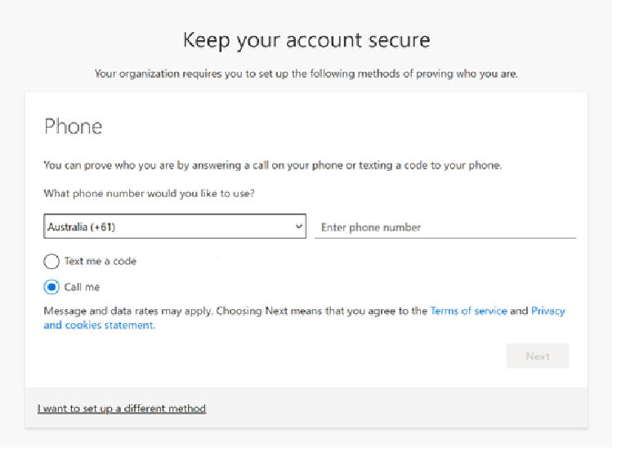
Click Call Me
Enter phone number
Click Next

d) You will receive a call to verify the number.
Answer the Call and press the # key on your mobile or landline’
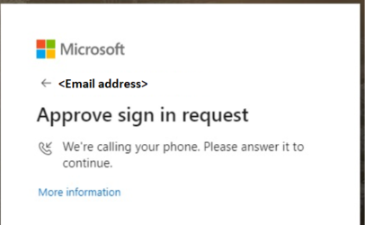

e) A notification will appear on your computer to indicate the set up for Multi factor Authentication using Phone Call Back has been completed and is all ready to go.
Click ‘Done’

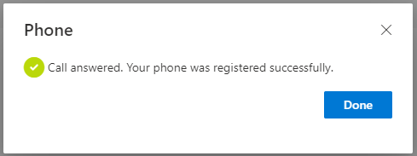
Click Done

f) You have successfully setup MFA in preparation for when bluescopesteelconnect begins to request the extra security

